Registration Form of ICICSP 2023 (Listener)
September 23-25, 2023 | Xi’an, China
http://www.icsp.org/

- Personal Information
First Name: |  | Family Name:
Position: Professor/ Associate Professor/ Assistant Professor/ Lecturer/ Ph.D Candidate/ Postgraduate/ etc… |  |  | (photo)
Organization or University:
Research Area:
Country: | Email:
Mobile: | Mobile phone:
Special Needs or Dietary Requirements:
Vegetarian □ Muslim □ Other (please specify):
All the payment receipt/invoice would be distributed onsite in general, please select the suitable one.

□ International Receipt (Receipt Title):

□ 国内专用发票 (提供发票抬头，统一社会信用代码，发票内容，开户银行名称、账号、地址及联系电话, 发票内容仅以下可选：“会议服务费”)

□ 国内普通发票 (提供发票抬头，统一社会信用代码以及发票内容，发票内容仅以下可选：“会议费”、“会务费”、“会议服务费”、“会议注册费”“会议服务（资料）费”)

One Day Tour: Yes or No
If you are planning to join in one-day tour, please register before Aug. 15, 2023. The fee of one-day tour is 80 USD/550 RMB.

- Registration Fee
Categories | Regular
Listener | 300USD/2000RMB
One Day Tour | 80USD/550RMB per one

Note:
Listener: participating in the conference only with neither presentation nor paper publication.
- Paying Method
Option 1: Online Payment
- Credit Card Paying Method
http://confsys.iconf.org/online-payment/890003173
(Please make sure you have VISA or Mastered Card Credit Card before clicking this link, and you should also calculate the right amount and pay.)
Please fill in the E-mail and Confirmation Number after paying.
E-mail: | Confirmation Number:
- PayPal
Account: pay@academic.net
Please fill in your information after bank transfer.
Please note that the handling charge for PayPal is 30 USD, so if the fee for you is 300 USD, please pay 330 USD.
Please fill in your information after bank transfer.
Remittance Name
Remittance Ammount
Remittance Email Address
Transaction ID
Remittance Date

Option 2: Bank transfer (Chinese author only)
宗杭户名：成都宗杭会展服务有限公司 （错别字有可能会导致无法成功转账，请仔细核对）
账户号：129316274303
开户行：中国银行成都市成飞支行
联行号: 104651081260
汇款完成后请把汇款回执单与其他资料一同返回，并填写以下信息：
汇款方户名(个人姓名或单位 )
汇款日期
汇款金额
注意: 如汇款后不提交注册资料到会议邮箱, 不视作注册成功, 文章无法按时出版！

Note:
- Registration can only be confirmed when payment proof has been received.
- All participants should prepare visa, air tickets, room reservation and other matters by themselves before the conference.
- Cancellations must be received in writing (email) to the Conference Secretary. Cancellations will not be deemed to be received until you have written confirmation from the Conference Secretary.
- Cancellation before August 15th, 2023 will be acceptable. 70% refund for cancellations received before and on August 15th. There will be no refunds for cancellation after August 15th, 2023.
- The losses thus incurred from the force majeure events shall not be liable and refunds policy shall not apply as well.
- The organizing committees reserves the right to change the dates and place of the conference due to force majeure.
- The registration fee cannot be refunded due to any reasons caused by conference participants, such as, visa, etc.
- Please take care of your safety and all personal belongings, and wear your name tags during the whole conference. No responsibility or liability is accepted by conference organizer in respect of any loss or damage.

PLEASE RETURN the completed Registration Form and Payment Proof to icicsp@vip.163.com before August 15, 2023.
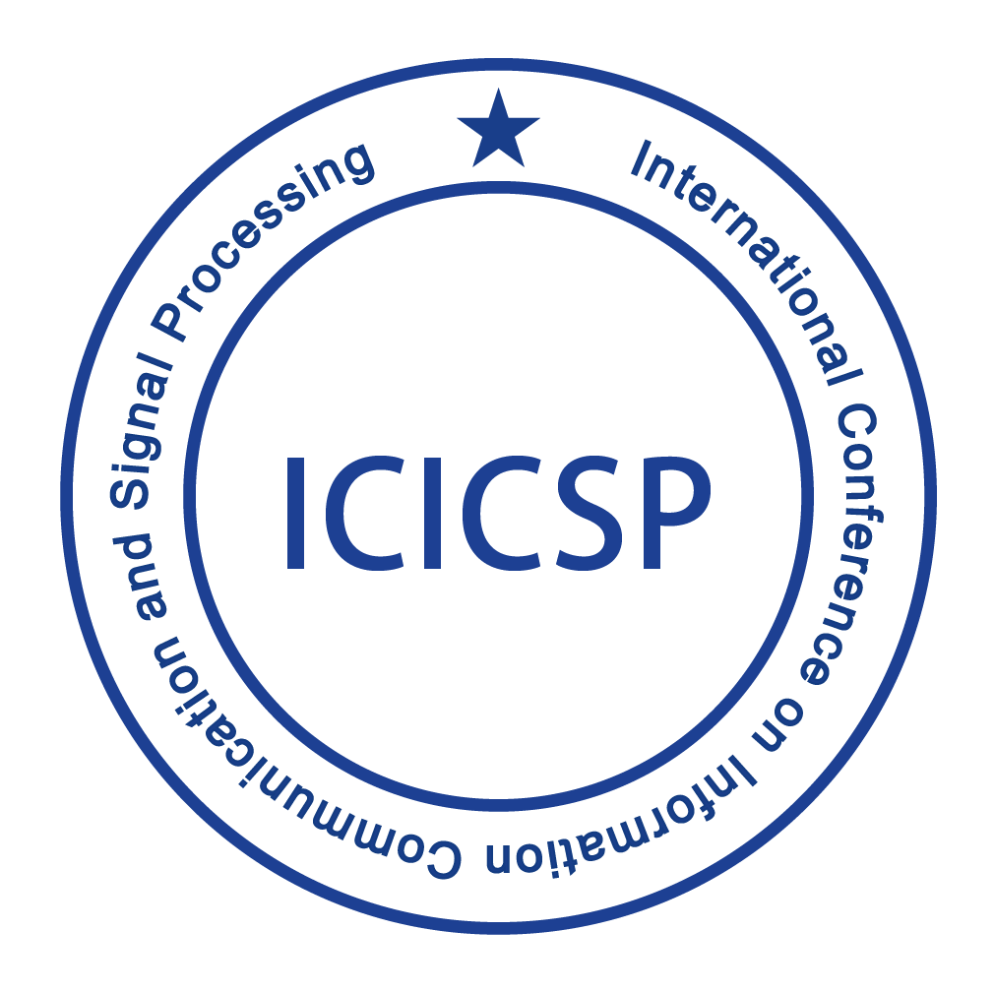

ICICSP 2023 Organizing Committee
http://www.icsp.org/
Xi’an, China

